farcebook | Home Profile Friends Inbox (1) |  |  |  |  |  |  |  | Settings | Log out
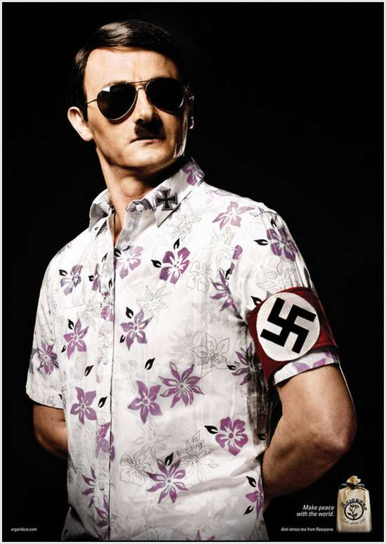 |  |  | Adolf Hitler: |  |  | Dictator of Germany |  |  | 5 minutes ago
 |  |  | Wall |  | Info | Photos | +
 |  |  |  | What’s on your mind?
Basic Information
 | Networks: | Berlin, Germany
 | Birthday: | April 20th, 1889
 | Hometown: | Braunau am Inn, Austria-Hungary
 | Relationship Status: | Married
 | Political Views: | Nazi fo’ life
Bio:
Dictator of Germany. Heil me. I despise freedom, Jews, and losing wars. I enjoy, painting, killing inferiors, taking over the world, and fluffy kittens.
Favourite Quotations:
“Germany will either be a world power, or not be at all
Personal Information
 | Activities: |  | Painting; Hunting Jews
 | Interests: |  | World domination; lebensraum; long walks on the beach
 | Favourite Music: |  | Hitler is our saviour
 | Favourite Movie: |  | The boy in the striped pyjamas
 | Favourite Books: |  | Mein Kampf

View photos of me (34)
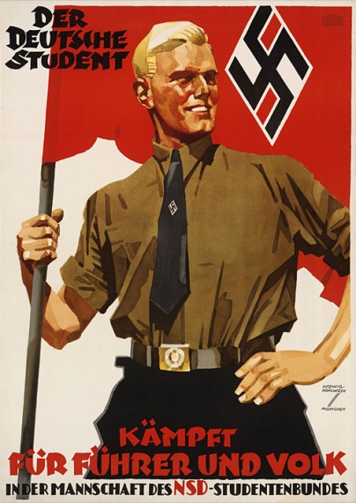
Information
Relationship Status: Married
Current City: Berlin, Germany
Birthday: April 20th
Friends
Benito Mussolini |  | Hideki Tojo |  |  | Heinrich Himmler
Joseph Goebbels |  | Miklos Horthy |  |  | Rudolf Hess

farcebook | Home Profile Friends Inbox (1) |  |  |  |  |  |  |  | Settings | Log out
 |  |  | Adolf Hitler: |  |  | Dictator of Germany |  |  | 5 minutes ago
 |  |  | Wall |  | Info | Photos | +
 |  |  |  | What’s on your mind?
Berlin is lost. I cannot let myself be captured by those Jew-lovers. May Germany live on
It’s a nice day today. Maybe I’ll take the day off and have picnic
Another failed assassination attempt. Just give up already
Taken over by Germany today #fml
Book burning today. Bring your own marshmallows
Why did you break the peace agreement? Fine, I’ll take my talents to the allies
Please stop taking over countries. It’s not very nice
Like if you’re Jewish
Lost my razor again. Guess the moustache is staying.

View photos of me (34)
Send a message
Poke message
Information
Relationship Status:
Married
Current City:
Berlin, Germany
Birthday:
April 20th
Friends
Benito Mussolini |  | Hideki Tojo |  | Heinrich Himmler
Joseph Goebbels |  | Miklos Horthy |  | Rudolf Hess

