farcebook | Home Profile Friends Inbox (1) |  |  |  |  |  |  |  | Settings | Log out
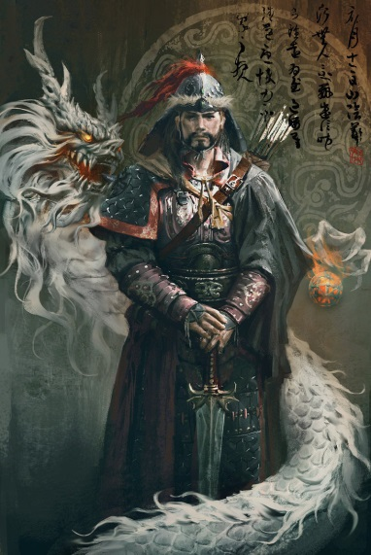 |  |  | Genghis Khan |  |  |  |  |  | 5 minutes ago
 |  |  | Wall |  | Info | Photos | +
 |  |  |  | What should I do taday; Take over a country or take a walk on the beach????
Basic Information
 | Networks: | Anywhere in Asia ( because I took it all)
 | Birthday: | Born 1165 died 1227
 | Hometown: | Somewhere in Mongolia
 | Relationship Status: | As many wives as I can get
 | Political Views: | Take over what I want
Bio:
I am the best conqueror this world will ever see. No one has yet to stop me and no one will ever stop me. I have taken over all of Asia just because I felt like it. Who knows where I might go next.
Favorite Quotations:
“I am the punishment of God...If you had not committed great sins, God would not have sent a punishment like me upon you.”

“If you're afraid - don't do it, - if you're doing it - don't be afraid!”-
Personal Information
 | Activities: |  | Taking over Asia,
 | Interests: |  | Drinking tea, Killing millions of people, and spending time with my mom
 | Favourite Music: |  | English Dance, Hardcore rock
 | Favourite Movies: |  | Mongol, The Lion King
 | Favourite Books: |  | The Art of War, Birth of an empire

View photos of me (34)
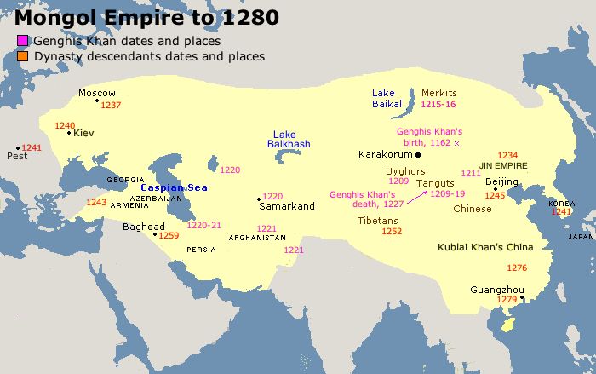
Information
Relationship Status: Quad divorcee.
Current City: Anywhere because I owned it all
Birthday :Born 1165 died 1227
Friends
Kublai Khan |  | Batu Khan |  | Jochi Khan
Ögedei Khan |  | Chagatai Khan |  | Tolui

farcebook | Home Profile Friends Inbox (1) |  |  |  |  |  |  |  | Settings | Log out
 |  |  | Genghis Khan |  |  |  |  |  | 5 minutes ago
 |  |  | Wall |  | Info | Photos | +
 |  |  |  | What’s on your mind?
Lol China thinks that a big wall to stop me!!
My dad wouldn’t name me as his first born. I’m going to go take over a village. That usually makes me happy
Took me about four years but I got China. Whoop Whoop.
I fell of my horse and I’m really sore but I think I’ll be alright.
Hey so my dad died so I guess that makes me the leader now right??
Well, today was my 6th wedding. Everyone wish me luck that this one will last more than a week.

View photos of me (34)
Send a message
Poke message
Information
Relationship Status: Whoever I want
Current City:
Western Xia
Birthday:
1165
Friends
Kublai Khan |  | Batu Khan |  |  |  |  | Jochi Khan
 |  |  |  |  |  |  | (pic of possible friends)
Tolui |  |  |  |  |  |  | (Name)

